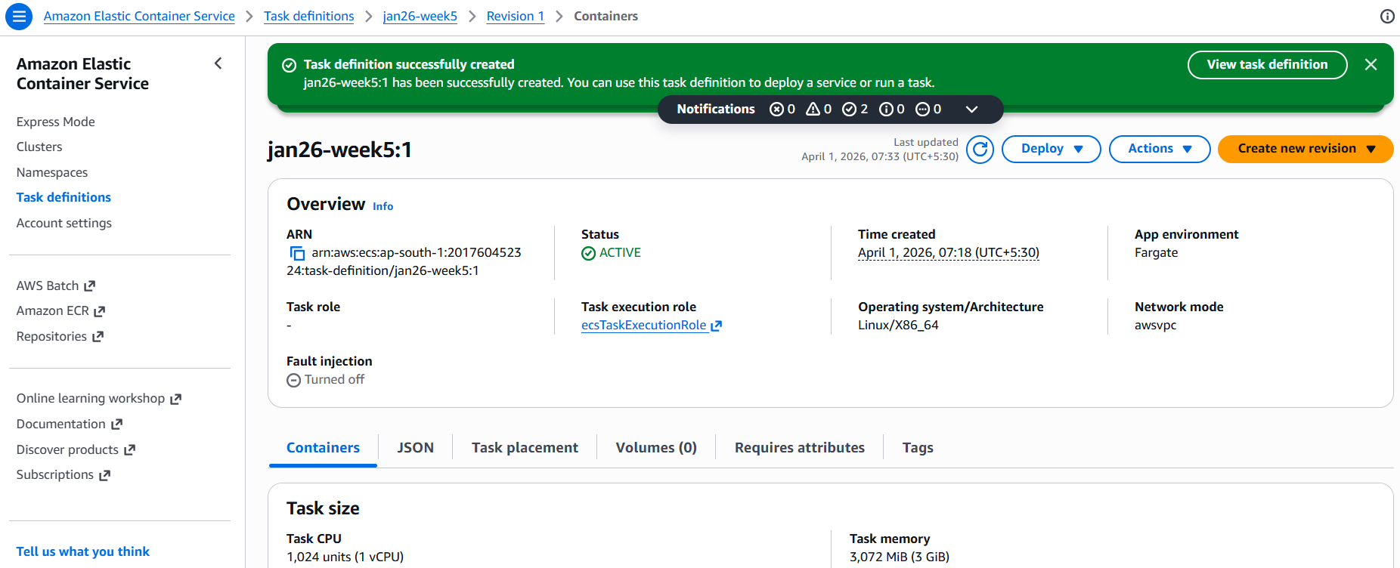

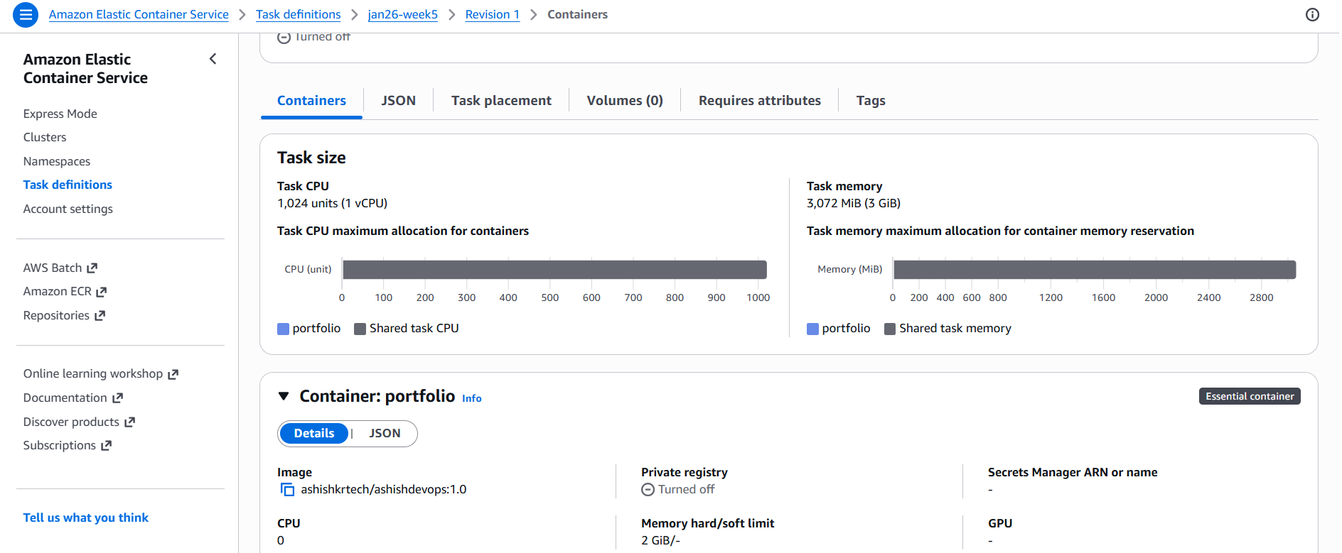

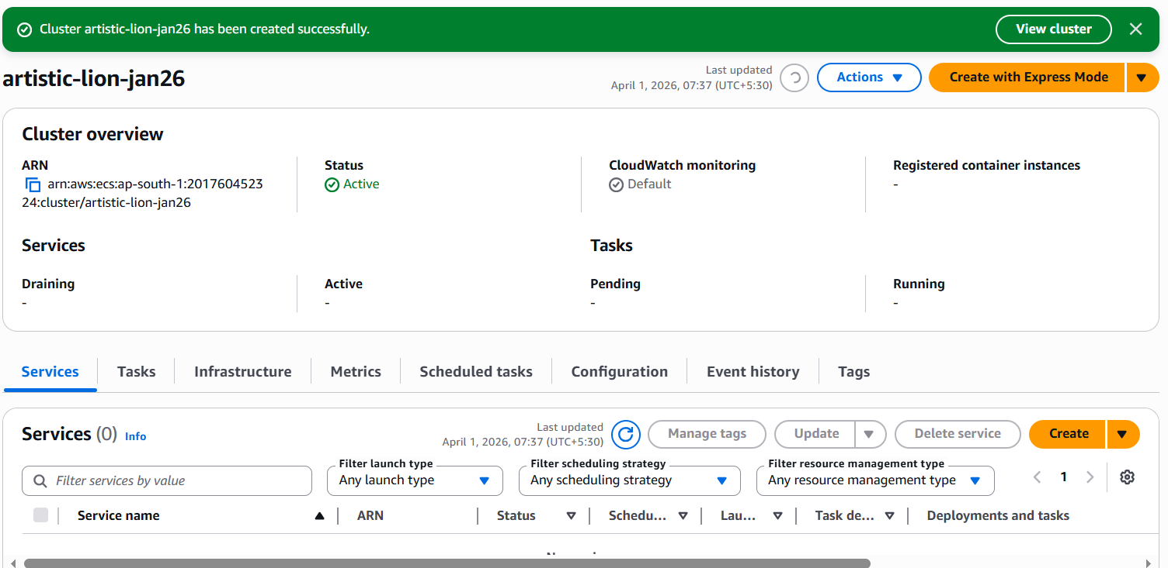

Tasks created
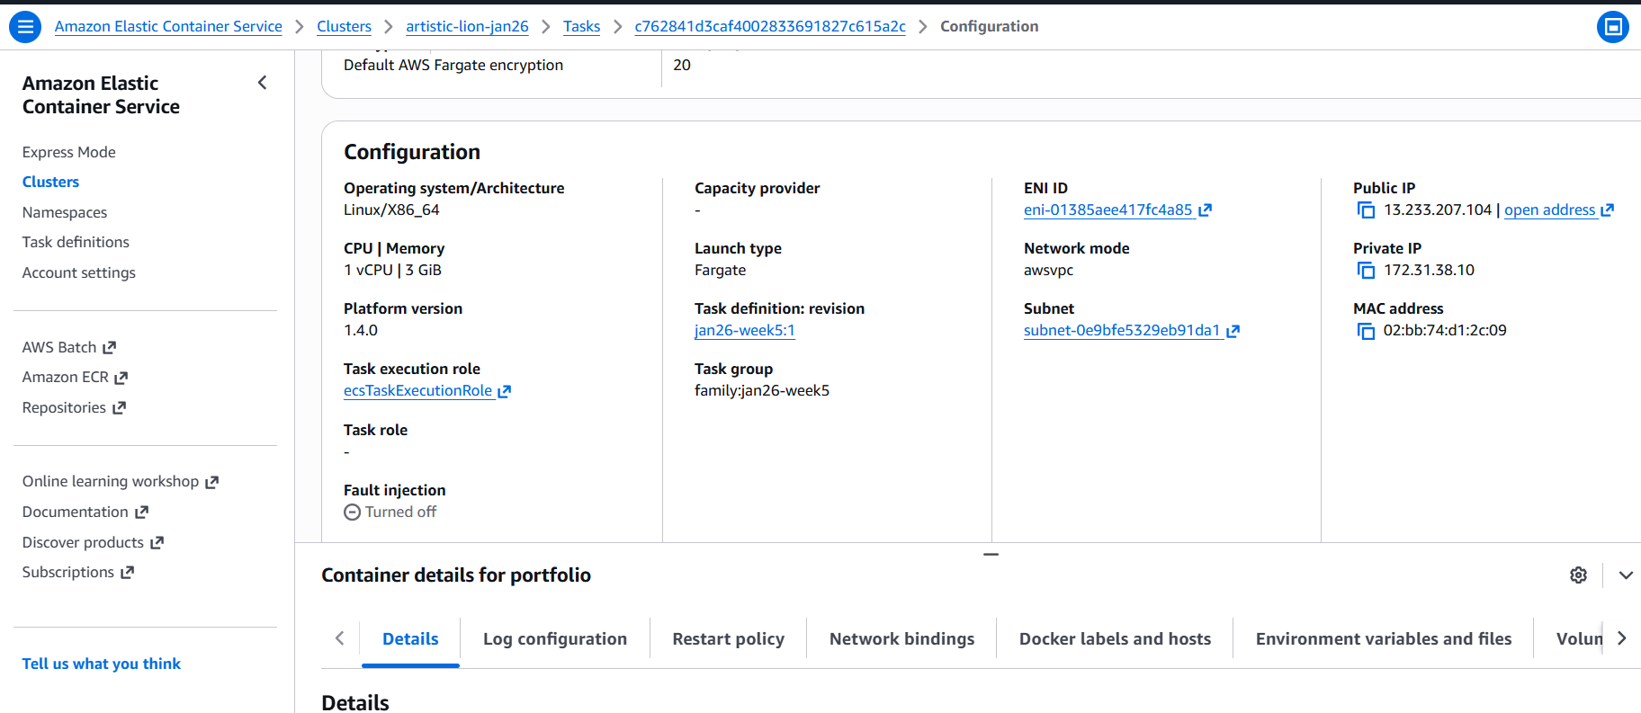

Open the public IP in a new tab and entered port 8000, I can access my portfolio website



Resume:
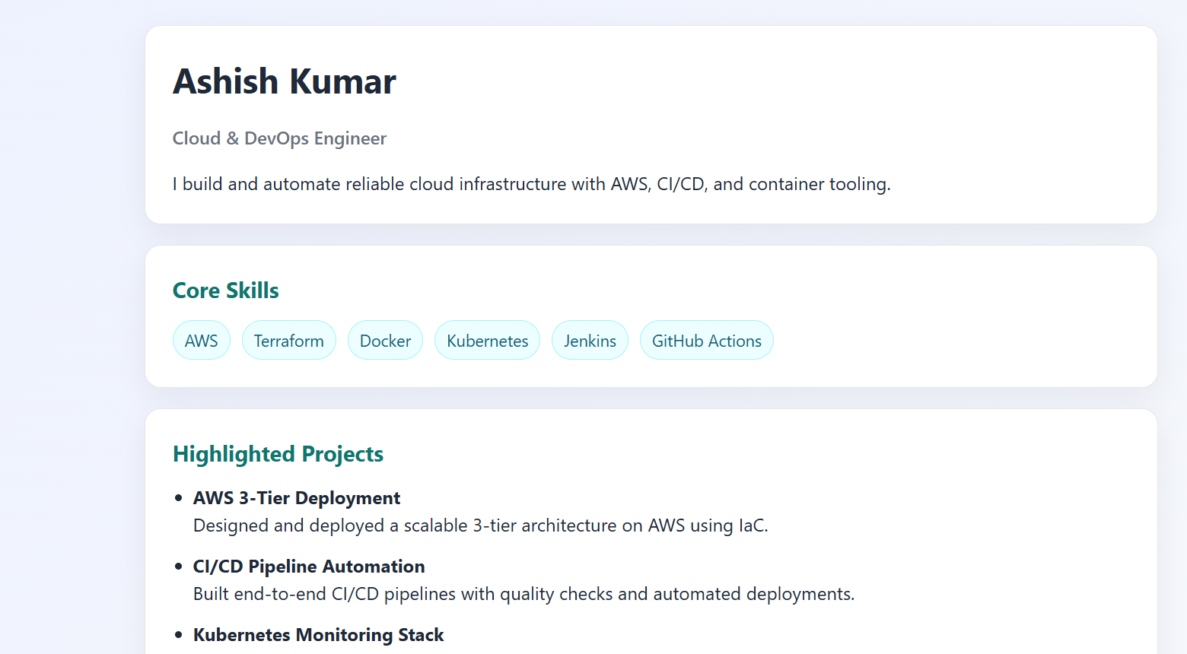

Creating a private repository for our custom made docker images

Created priv repo in AWS
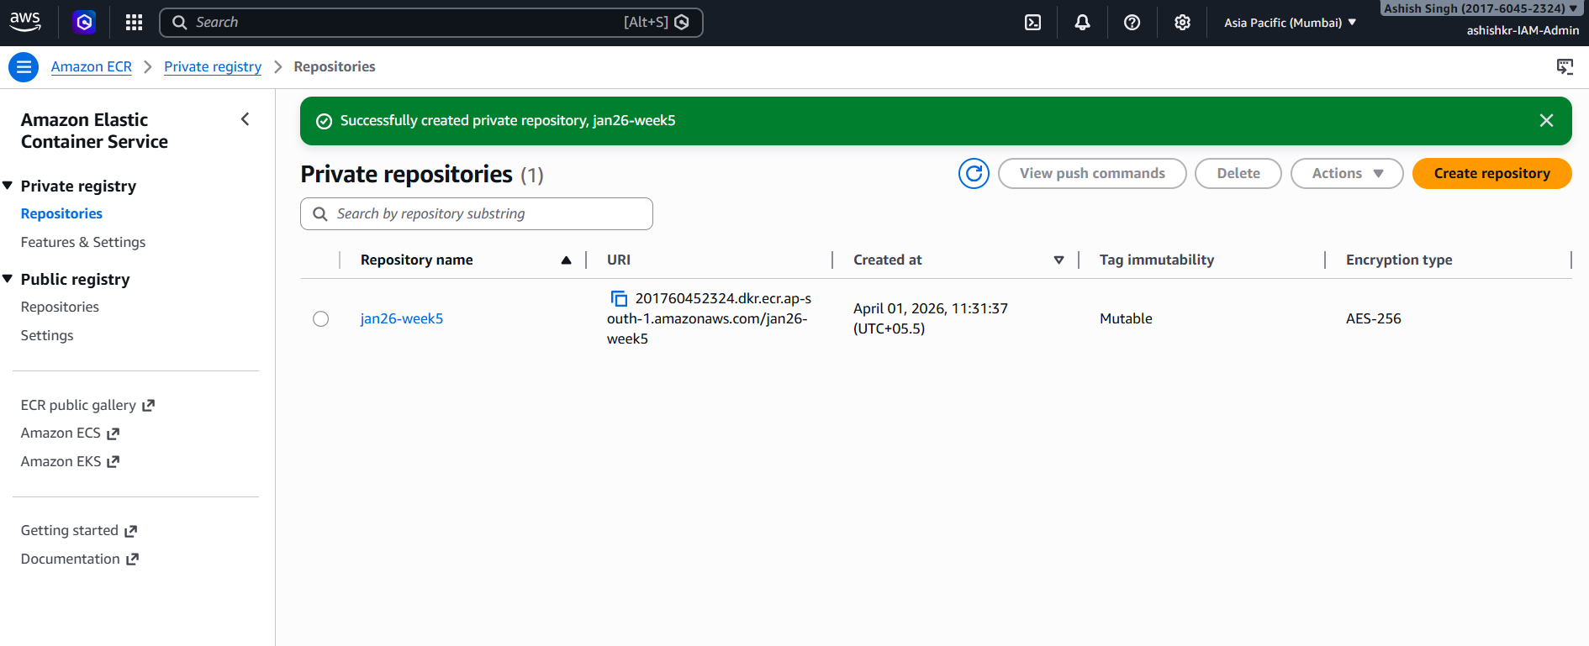

set up AWS credential to use cli to access aws resources.

Then, run
aws ecr describe-repositories --repository-names <ecr-repo-name>
- This will show details about the repo you creted—so terminal can access the ecr
- 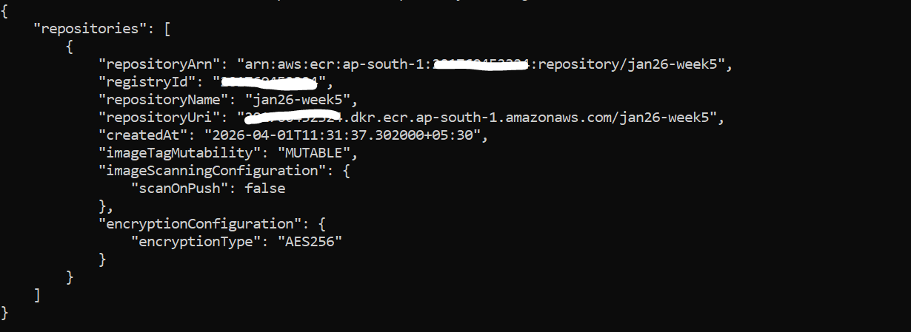
Next, Tag your image with the ECR repository URI.
The image must be tagged with the full ECR repository URI format: <aws_account_id>.dkr.ecr.<your-region>.amazonaws.com/<repository-name>[:tag]..

Run:
docker tag <local-image-name>:<tag> <aws_account_id>.dkr.ecr.<your-region>.amazonaws.com/<repository-name>[:tag]
(you can find URI from the repo in console)

Then you have to Authenticate Docker client with ECR registry using the AWS CLI, for that you have to run this command
aws ecr get-login-password --region <region> | docker login --username AWS --password-stdin <aws_account_id>.dkr.ecr.<region>.amazonaws.com

this command is a one-liner used to log Docker into AWS Elastic Container Registry (ECR) so you can push/pull container images.

What it does Get a temporary password from AWS, then use it to log Docker into my private ECR registry.”
- aws ecr get-login-password --region <region>
  - • Uses AWS CLI to request an authentication token
  - • This token acts like a temporary password
- Pipe (|) passes it to Docker
  - • Takes the password output and sends it directly into the next command
  - • Avoids exposing the password in plain text
- docker login --username AWS --password-stdin <registry-url>
  - • --username AWS → required by ECR (fixed username)
  - • --password-stdin → securely reads password from input (the pipe)
  - • <registry-url> → your private ECR repo endpoint

Finally, use the docker push command to upload your image to the ECR repository.
docker push <aws_account_id>.dkr.ecr.<region>.amazonaws.com/<repository_name>:latest

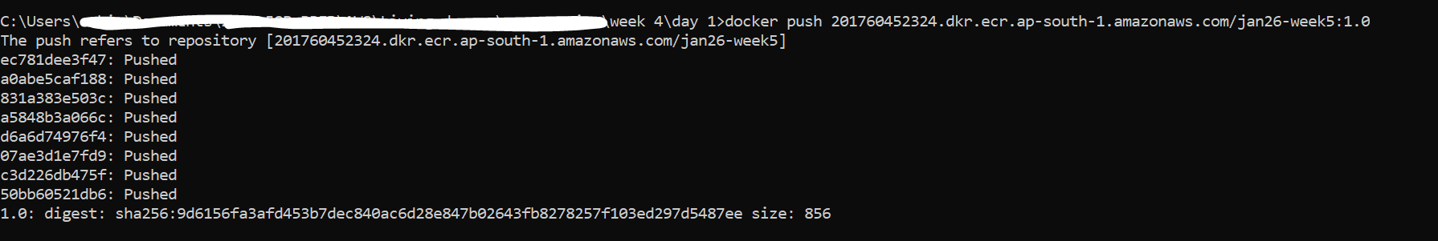

Then go to ECS, start a new revision of the task definition you created previously, in the image tag in json, change it to the image pushed into ECR repo.
